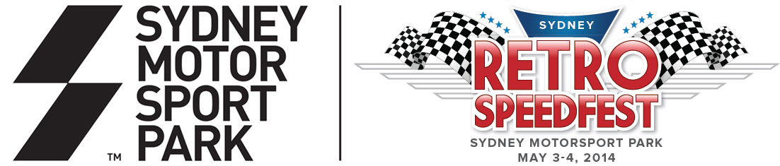

SYDNEY RETRO SPEEDFEST

SUNDAY MAY 4

SYDNEY MOTORSPORT PARK

PIT STRAIGHT CAR CLUB CORRAL REGISTRATION

Club & Individual Registration Form
Cars displaying a PIT STRAIGHT CAR CLUB CORRAL windscreen sticker may enter via gate B (formally gate 4 located off Peter Brock Drive) and park trackside in the exclusive PIT STRAIGHT CAR CLUB CORRAL area along Pit Straight. Passes and final instructions will be mailed after CLOSING DATE Friday April 18, 2014.

Drivers admitted free of charge and passengers pay at gate B as per spectator fees.

At gate: Adults - $35 (includes admission to competitor paddock & grandstand)
At gate: Concession - $25 (includes admission to competitor paddock & grandstand)
Children 12 & under FOC
PRE BOOK AND SAVE. For pre bookings discount phone 02 96721000

Club Name: _____________________ or Individual Contact Name: _________________
(If applicable)
Address: ________________________________________________________________

Phone: _____________________________ Email: _____________________________

Vehicle Type: _______________________________ Year: _________________
CLOSING DATE: Friday April 18 2014
CAR CLUBS TO FILL INFORMATION BELOW (Note: non-club members fill above)

NAME | CAR | ADDRESS FOR PASSES

PIT STRAIGHT CAR CLUB CORRAL
Club & Individual Master Registration Form

NAME | CAR | ADDRESS FOR PASSES

